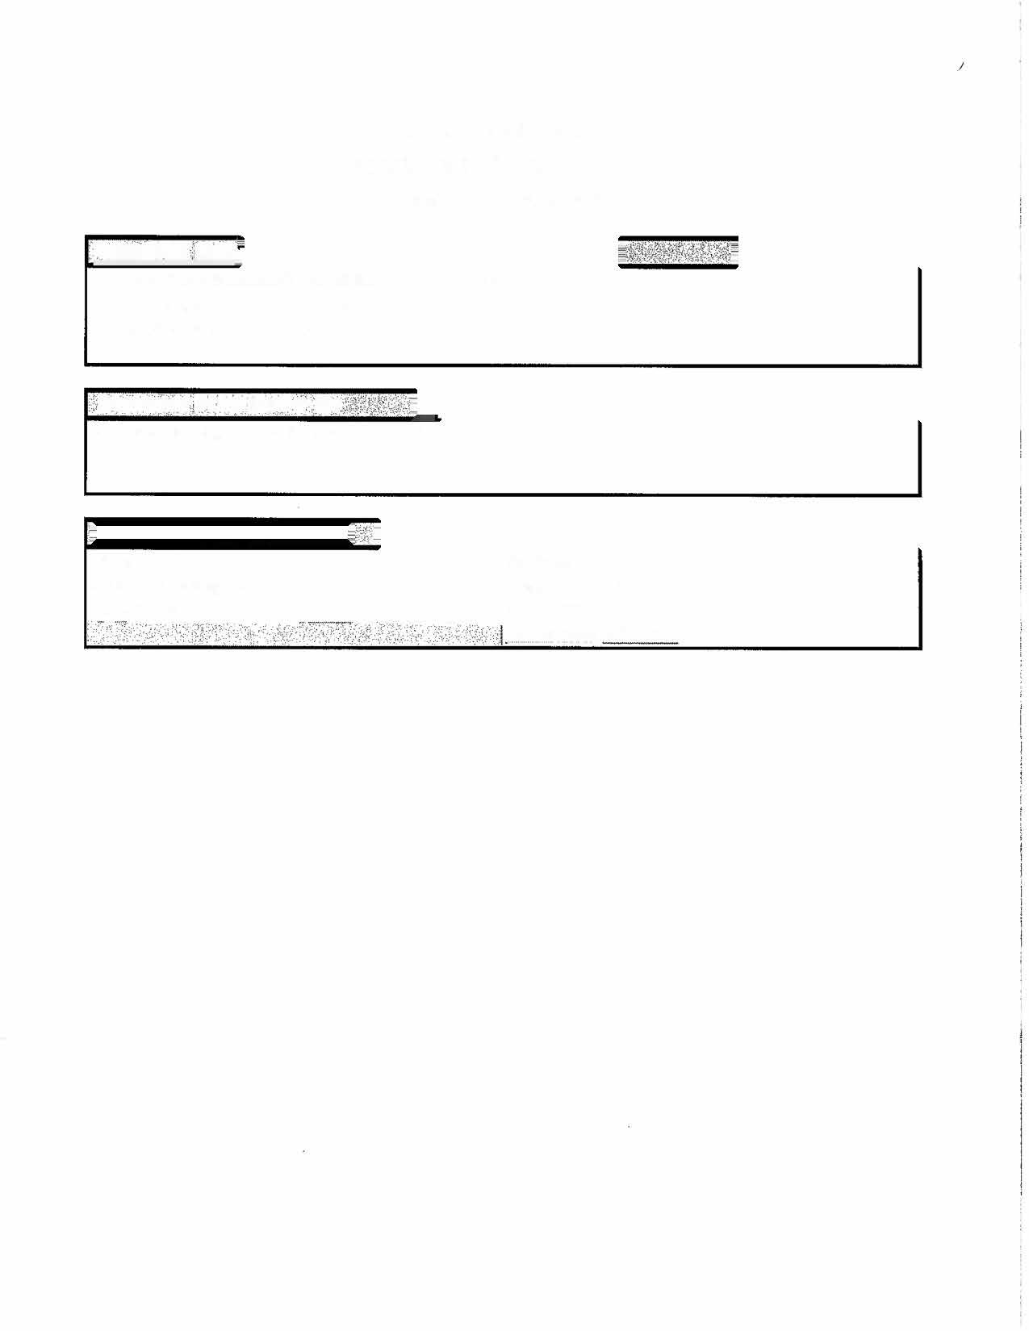
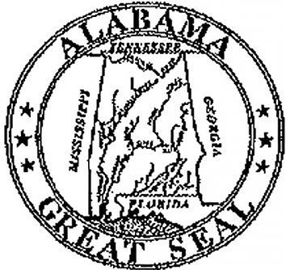
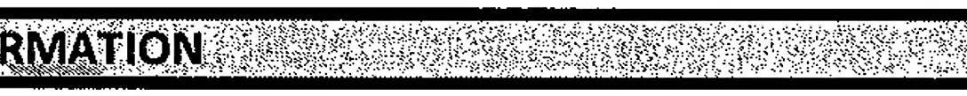
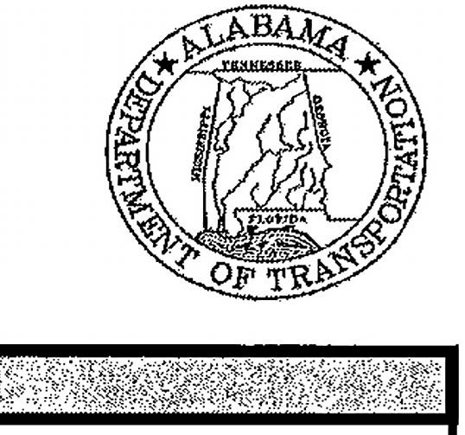
State of Alabama
Department of Transportation
Master Agreement
<
cQNTBA¢111NllQ

MASTER AGREEMENT NUMBER:
Begin Date:
9
/1/2026
Expiration Date:
8
/31/2027
•
CONTRACT
liiESC'RlP
T
.
lbN
. '
.
'
.·'.f:·
.... -
.
.
'
•

-
Roadside Mowing & Litter Removal District 14
Name/A ddress:
Lovin Contracting Co. Inc.
82
8
-479-9462
24-018
Contact:
Brandon K. Lovin
PO Box 758
..

·•:e..:..:c.
.::.___
____

--·---
Robbinsville,
NC 28771

