CONTRACT INFORMATION

State of Alabama Department of Transportation Master Agreement

MASTER AGREEMENT NUMBER:
Begin Date: 5/16/2026 Expiration Date: 5/15/2027
24-015

CONTRACT DESCRIPTION
Vehicle Detection for Hybrid Video, Microwave and Radar Detection Systems

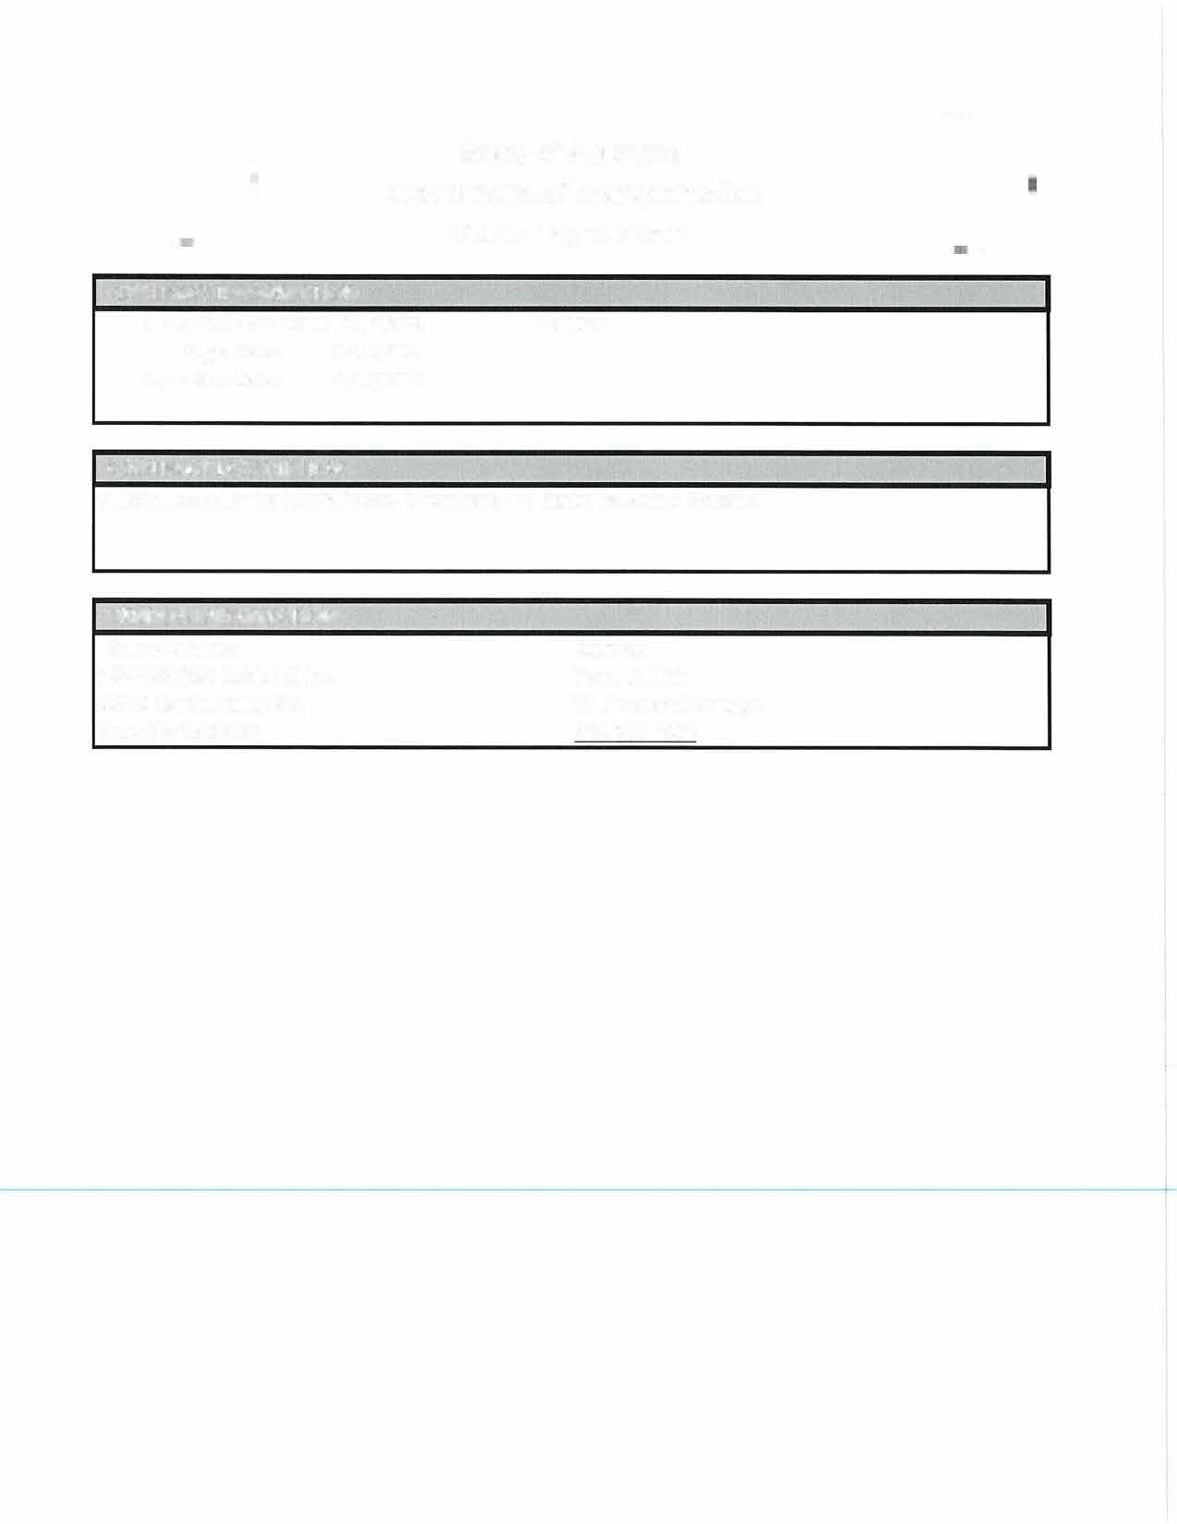


VENDOR INFORMATION

Name/Address:
VC000057929 Cubic ITS Inc.
10545 Hardin Valley Rd. Knoxville TN 37932

Contact:
Preston Walker
Senior Sales Account Executive/ (662) 801-0320 Preston.Walker@cubic.com

Contract Line Items
Line # | Description | Unit Price
00001 | APPROVED SYSTEMS REQUIRED TO PROVIDE VEHICLE DETECTION. SYSTEMS TO BE PROVIDED AT % DISCOUNT OFF LIST PRICE. VENDOR MUST LIST THE UNIT PRICE FOR THIS LINE ITEM AS A PERCENTAGE OFF LIST PRICE IN THE UNIT PRICE FIELD AND THE MANUFACTURER IN THE BLANK SPACE PROVIDED:_____Cubic ITS, Inc.______. FAILURE TO ENTER THE PERCENTAGE DISCOUNT IN THE UNIT PRICE FIELD WILL CAUSE THE TITB TO BE REJECTED. | 2%
00002 | PARTS AND COMPONENTS REQUIRED TO REPAIR VEHICLE DETECTION EQUIPMENT. PARTS TO BE PROVIDED AT % DISCOUNT OFF LIST PRICE. VENDOR MUST LIST THE UNIT PRICE FOR THIS LINE ITEM AS A PERCENTAGE OFF LIST PRICE IN THE UNIT PRICE FIELD AND THE MANUFCATURER IN THE BLANK SPACE PROVIDED: _Cubic ITS, Inc. . FAILURE TO ENTER THE PERCENTAGE DISCOUNT IN THE UNIT PRICE FIELD WILL CAUSE THE TITB TO BE REJECTED. | 2%
00003 | LABOR, COST PER HOUR TO REPAIR VEHICLE DETECTION EQUIPMENT. VENDOR MUST LIST THE UNIT  PRICE FOR THIS LINE ITEM AS THE HOURLY REPAIR RATE. | $188.00
00004 | TECHNICAL SUPPORT FOR SYSTEMS, 1 DAY (STATEWIDE). 1 SERVICE TECHNICIAN INCLUDING ALL TRAVEL, LODGING, AND MEALS. (OPTIONAL) | $2,500.00
00005 | FREIGHT

