State of Alabama Department of Transportation
Master Agreement

MASTER AGREEMENT NUMBER:
Begin Date: 2/01/2026 Expiration Date: 1/31/2027

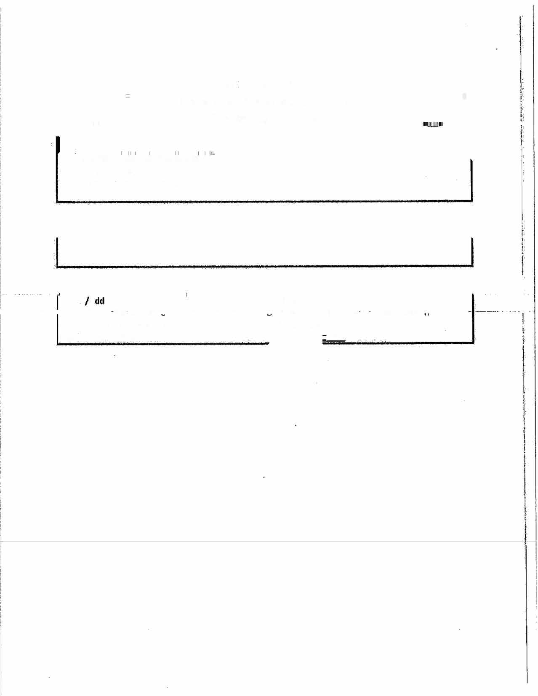




Name A ress: Contact:
Ennis Flint, Inc. (VC000058192) Dane Alsabrook-Director of Contract Admin
4161 Piedmont Parkway Suite 370 336-308-3794
Greensboro, NC 27410 .com

- - lJ_ _

Line # |  |  |  |  |  |  |  |  | Description |  |  |  |  |  | UOM | Unit Price
1 |  | TMERMOPLASTIC, CLASS 2, PAVEMENT MARKING MATERIAL, ALKYD/MALEIC, WHITE, IN 50 LB.  GRANULAR- NON BLOCK. |  |  |  |  |  |  |  |  |  |  |  |  | TON | $1,555.34  Increase Effective  05/15/2026
2 |  | TMERMOPLASTIC, CLASS 2, PAVEMENT MARKING MATERIAL, ALKYD/MALEIC, YELLOW IN 50 B.  GRANULAR- NON BLOCK. |  |  |  |  |  |  |  |  |  |  |  |  | TON | $1,555.34  Increase Effective  05/15/2026

